


AWS Solution Architect Training with AWS Cloud Practitioner Global Certification Training
Capstone Projects

Trainer: Aravindraj.G- Nminds Academy
AWS Academy Certified Educator

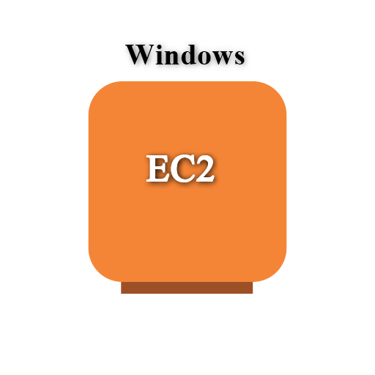

Configure IIS Webserver on Windows Server in AWS

Gokul.S

Objective

An EC2 Windows instance is a virtual machine running the Microsoft Windows operating system on Amazon Web Services (AWS) EC2 (Elastic Compute Cloud). This allows you to run Windows-based applications, manage Windows Server configurations, and use various Microsoft software (like SQL Server, IIS, etc.) in the cloud without having to manage physical hardware.

IIS (Internet Information Services) is a web server software created by Microsoft for hosting websites and web applications on Windows Server operating systems. It provides a platform for building, deploying, and managing web-based applications. IIS supports multiple protocols, including HTTP, HTTPS, FTP, and more, and is tightly integrated with the Windows OS.
Common Use Cases of IIS:
- Hosting Websites: IIS is often used by businesses and developers to host websites and web applications, particularly those built with ASP.NET.
- Web Applications: For applications that require robust back-end support, IIS provides features like application pooling and security for web services (e.g., SOAP or RESTful APIs).
- Secure File Sharing: IIS can be configured as an FTP server to securely share files between different locations.
- Application Hosting in Enterprises: Many enterprise applications built on Microsoft technologies rely on IIS for deployment, such as SharePoint, Exchange Server, or Dynamics CRM.
- API Hosting: IIS is commonly used to host APIs (e.g., RESTful services) built with .NET or other technologies.

Used Services in AWS Used Services in Windows Server
IIS- Internet Information Services

Amazon EC2

Topology

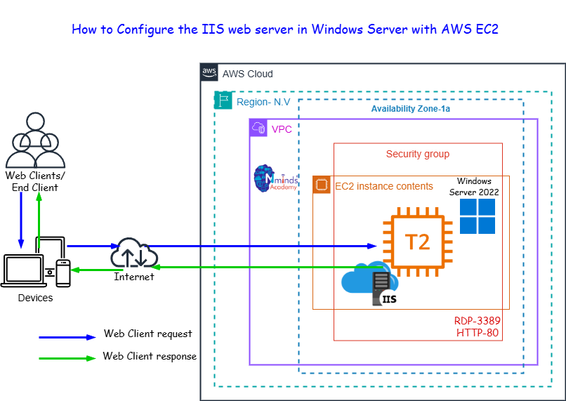

Execution Tasks:

